Classroom Counseling Lesson Plan
Lesson Title | Grade Range | Time Needed
Understanding Learning Styles | 6-8 | 45 minutes

Domain | Mindset Standards | Behavior Standards
Career/Academic | 1, 4, 5 | LS1, LS3 LS4, LS6, SMS1, SMS7, SMS10

Learning Objectives:
- Students will be knowledgeable about learning styles.
- Students will become self-aware of their learning style.
- Students will understand how to utilize their learning style to be successful in both school and the world of work.
Supplies/Materials:
- “Learning Styles” posters (attached)
- “What Am I?” handout (attached)
- Gloop Recipe (attached) and necessary materials
- “Learning Styles Self-Assessment & Practical Learning Suggestions” handout (attached)
- (Optional) “Learning Styles Assignment” handout (attached)

Rationale: Students will discover, through participation in class activities and a learning styles assessment, more about the natural ways they think and learn, and how this learning style knowledge can be applied to educational learning tasks.
Outline:
- Before starting this lesson, tape up “Learning Styles” posters throughout the room.
- Inform students about the definition of learning styles.
  - Learning styles: the different ways people naturally think and learn
- Read BUT DON’T SHOW the “What Am I?” paragraph:
  - “I am a shimmer fluid polymer that is over 97% water. The water in me acts as a bridge linking polyvinyl alcohol to the sodium tetra borate through cross-linked hydrogen bonding. This cross linked polymer will shear if twisted and is endothermic as it flows, getting colder in your hands. WHAT AM I?”
- Tell students that some people who are verbal/linguistic (or auditory) learners may guess the answer just from hearing it out loud. Let students guess what they think it is.
- Show the paragraph (attached “What Am I?” handout) and read it again. Some students may guess the answer after seeing the words on the board. Explain that students who are visual/spatial prefer to see instead of just hear the information. Have students continue guessing what they think it is.
- Ask for a volunteer. Have a student mix up the ingredients (see attached “Gloop Recipe” handout) in a cup with a Popsicle stick. The solution will thicken until it becomes slime. Ask the student to show the others in the class and let them feel it. Some students will say it looks and feels like slime.
- Explain to the students we just made SLIME, also known as GLOOP!
- Tell students this process works because two molecules are floating around in some water. The water says, “Hey you two should be buddies,” and connects them together. They meet some other friends and they hook together and make a chain of four, and then it gets wild with everyone hooking up with everyone. Turns out they like each so much that if you try to get them apart they don’t want to separate and you have to literally teach them from each other. As for “becoming endothermic as it flows,” that means that is cold and absorbs eat from your hand.
- Inform students the reason we did this activity was to introduce people learn in different ways, and when students are aware of their learning styles they:
  - Are able to determine the best approach to learning something new
  - Can judge what kind of occupation would be suited for them based on their learning style
  - Do well in a career that uses their strongest learning styles
- Have each student complete the “Learning Styles Self-Assessment & Practical Learning Suggestions” (attached).
- Tell students according to Howard Gardner, there are seven different ways in which people demonstrate their intellectual ability. These are the Howard Gardner’s Seven Different Learning Styles:
  - Visual/Spatial Intelligence: ability to perceive the visual
  - Verbal/Linguistic Intelligence: ability to use words and language
  - Mathematical/Logical Intelligence: ability to use reason, logic and numbers
  - Bodily/Kinesthetic Intelligence: ability to control body movements and handle objects skillfully
  - Musical/Rhythmic Intelligence: ability to produce and appreciate music
  - Interpersonal Intelligence: ability to relate to and understand others
  - Intrapersonal Intelligence: ability to self-reflect and be aware of one’s inner state of being
  - (Note: 90% of all people are gifted in at least one area.)
- If time allows, you may also show this video clip entitled “Find Out Your Learning Styles” at http://www.youtube.com/watch?v=-Jwz_h0zXsY. The entire video is just over 9 minutes long. This clip is meant to be an exaggerated, yet fun way for students to see how each learning style is unique. It acts out a mystery within a school involving Dr. F and the Superhero Learners.
- Have students go to the poster on the wall (“Learning Styles” posters hung up around the room) that is most like them. Have each group discuss one study technique that might work for them in their learning style.
- Have students go back to their seats. Tell students to choose one class and use their best Learning Style to complete an assignment for that class. (The next time you visit the classroom for a lesson, follow up by asking students what they did and how it worked for them. OR, you can hand out the “Learning Styles Assignment” (attached) for students to complete and turn in.)
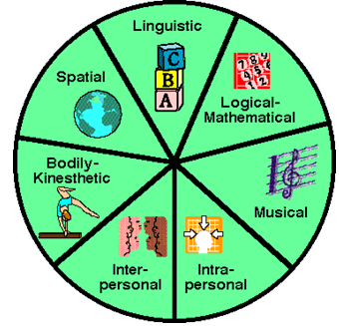

Adapted from: Utah State Office of Education. (2009). Career and technical education: Career
development lesson #9 understanding learning styles. Retrieved from:
http://www.schools.utah.gov/CTE/cteintro/Career-Development.aspx.

Verbal/Linguistic

Mathematical/
Logical
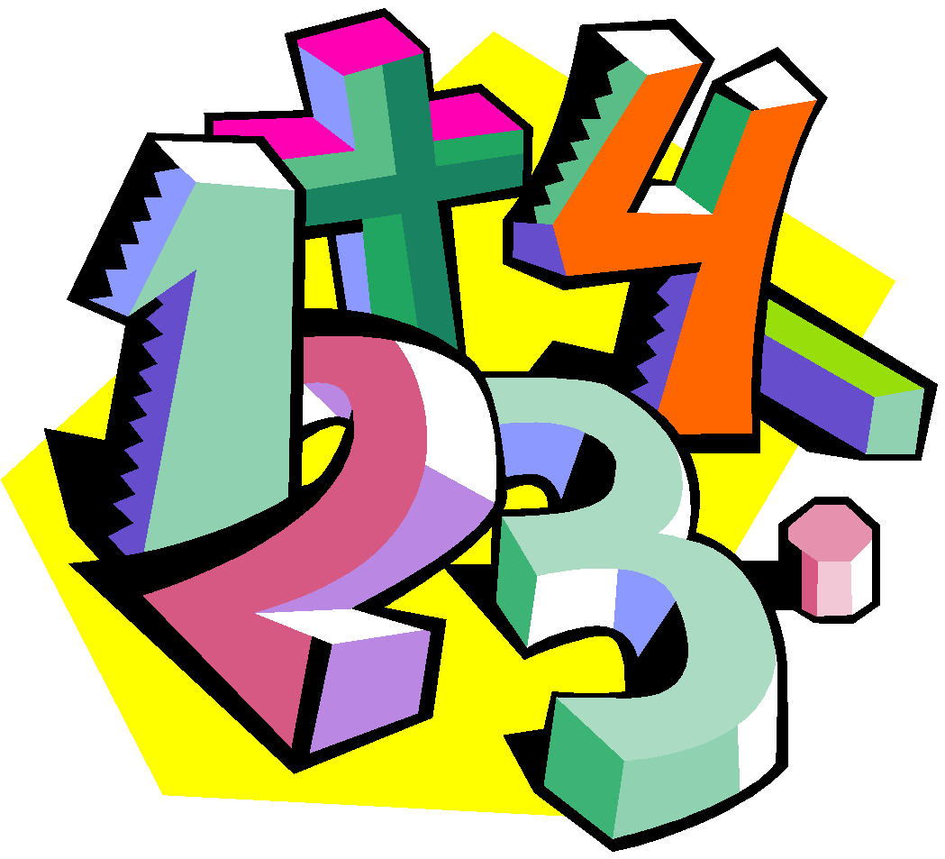
Visual/Spatial

Bodily/
Kinesthetic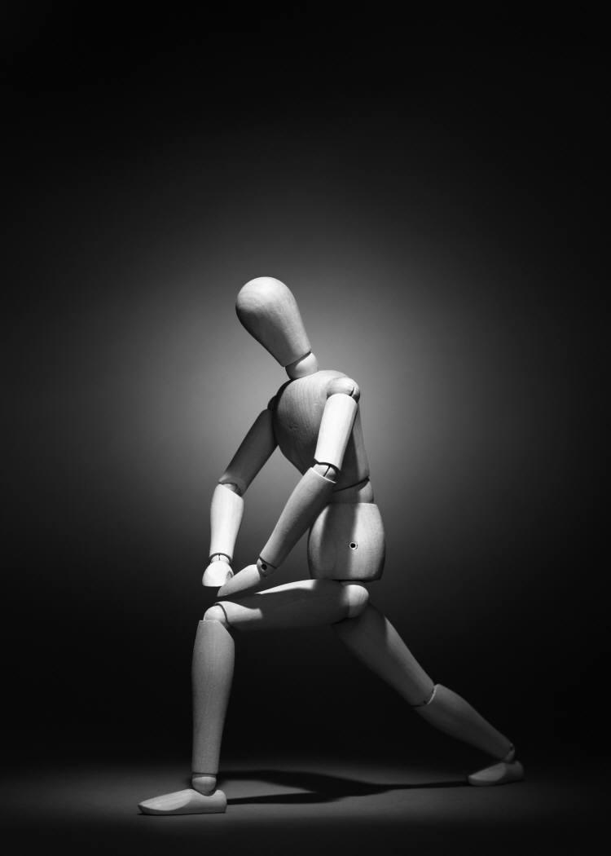

Music/Rhythmic

Interpersonal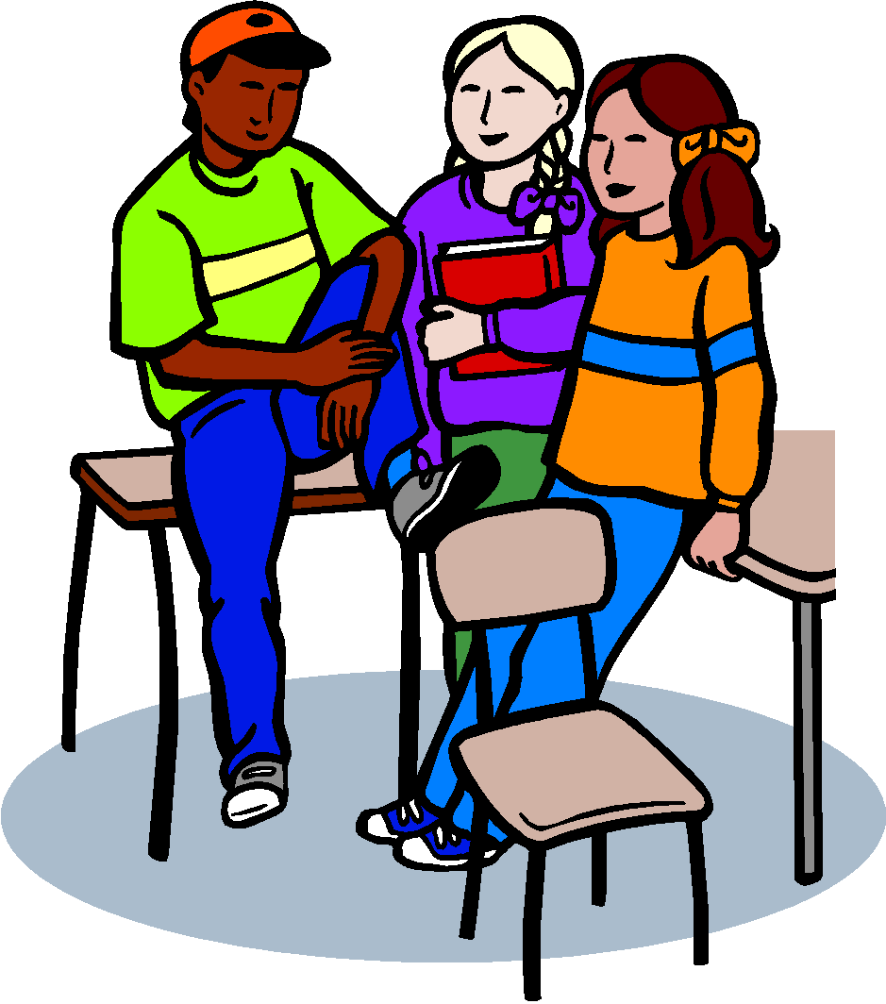
Intrapersonal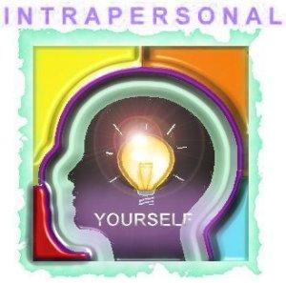

What Am I?
“I am a shimmery fluid polymer that is over 97% water. The water in me acts as a bridge linking polyvinyl alcohol to the sodium tetra borate through cross-linked hydrogen bonding. This cross-linked polymer will shear is twisted and is endothermic as it flows, making me colder in your hands.”
What am I?

There are a few different ways to make slime, or gloop. Here are two separate recipes and one way to order it.
Gloop Recipe
By: Jacob Albrecht
(This recipe may be easier to make than the one that originally came with the lesson plan. Instead of slime, it’s called Gloop.)
Ingredients:
- ½ cup Powdered Borax (20 Mule Team Brand – found in the laundry section of the grocery store)
- 2 cups water
- 3 tbsp. Elmer’s Glue
- Paper/plastic cup
- Plastic spoon
- Food coloring (optional)
Instructions:
Dissolve the Borax in water. Some will settle out – that’s ok. Take 3 tbsp. of the Borax solution and put it in a paper/plastic cup. Add 3 tbsp. of glue. Stir well. Soon, a rubbery substance will be stuck to your spoon. Roll this into a ball. It will be very bouncy. You can make gloop that is more like silly putty by adding a little water with the glue. You may mix it with food coloring to make it a different color if you want. Put gloop in a Ziploc bag to keep soft.

HOMEADE SLIME RECIPE FROM THE ORIGINAL LESSON PLAN:
Ingredients:
- Borax
- White glue
- Food coloring (optional)
- Ziploc bag
- Measuring cups and spoons
Instructions:
- Add 1 cup of water and add to 1 tbsp. of Borax (approx.. 4% solution). Stir until completely dissolved.
- Make a 50% water/50% white glue solution. Take ¼ cup of each and mix thoroughly.
- In a Ziploc bag, add equal parts of the Borax solution to equal parts of the glue solution. ½ cup of each will make a cup of slime.
- Add a couple drops of food coloring.
- Seal bag and knead mixture.
- Dig in and have fun. Remember to wash your hands after playing.
- Keep your slime in the sealed bag in the refrigerator when not playing with it to keep it longer. Unfortunately, it may eventually dry out or grow mold. Just throw it out and start again!

YOU CAN ALSO ORDER SLIME! www.stevespanglerscience.com PVA Slime Kit #WSLM-800 $16.99 + shipping
Includes:
1 Liter of PVA solution
½ Liter of cross-linker solution
Slime instructions guide – guaranteed to help you mix up a perfect batch of slime every time. This PVA solution contains specially formulated stabilizers to increase the shelf life. The kit makes 15 batches of slime (approx. 60 mL (2 oz.) portions). The kit could make up to 30 batches of slime by making 1 oz. portions. This recipe will be more shimmery and clear in appearance.

SAFETY: Not to be fed to your pet or baby brother. Not good for leaving in carpets or on furniture overnight. To keep most indefinitely, leave in a Ziploc bag in refrigerator when not sliming! Not a bad idea to wash hands before (so it doesn’t grow mold) and after playing with it (so Mom will let you eat dinner).

Learning Styles Self-Assessment & Practical Learning Suggestions
Name: ___________________________ Date: ____________________

Circle all the items on this page that describe you and total the number of items circles in each row on the right.
1. I like to read. | 8. I like to write. | 15. I enjoy doing crossword puzzles & word games. | 22. I like to tell stories and jokes. | 29. I have a large vocabulary. | 36. I choose words with care. | 43. I am good at public speaking. | A
2. Math & Science are some of my favorite subjects in school. | 9. I want to know why. | 16. I like solving riddles and brain teasers. | 23. I like finding number patterns. | 30. I believe there is a logical explanation for almost everything. | 37. I am good at working with numbers. | 44. I enjoy doing scientific experiments. | B
3. I enjoy using a camera or camcorder. | 10. I like to draw and doodle. | 17. I like to solve mazes and jigsaw puzzles. | 24. I easily see color and shape patterns. | 31. I am good at using or drawing maps. | 38. I often remember scenes from my dreams. | 45. I understand how to use colors to create a mood. | C
4. I am good at playing active games or sports. | 11. I like to dance. | 18. I often talk with my hands. | 25. I move around a lot when doing work projects. | 32. I like using objects to learn. | 39. I like to do work with my hands. | 46. I like to spend my free time outdoors. | D
5. I play a musical instrument. | 12. I like to sing. | 19. I like to tap out the beat while listening to music. | 26. I enjoy creating music. | 33. I often have a musical tune running through my mind. | 40. I have a good sense of pitch and rhythm. | 47. I like many kinds of music. | E
6. I enjoy group games. | 13. I enjoy helping others. | 20. I have many friends. | 27. I like working with others on projects. | 34. I like meeting new people. | 41. I care about how others feel. | 48. People often ask me for advice. | F
7. I have set some important goals for my life. | 14. I enjoy writing in a journal. | 21. I like to work alone. | 28. I like to spend time alone thinking. | 35. I think carefully before making decisions. | 42. I understand my strengths and weaknesses. | 49. I enjoy learning about myself. | G

The next page shows how to plug in these results to find your most dominant Learning Style(s) and how to use them to learn best.

Mark how many circles you had in each row on the right in the Learning Styles Self-Assessment, so you can see which Learning Styles are your most dominant.
________ Row A
Verbal/Linguistic Intelligence

________ Row B
Mathematical/Logical Intelligence

________ Row C
Visual/Spatial Intelligence

________ Row D
Bodily/Kinesthetic Intelligence

________ Row E
Music/Rhythmic Intelligence

________ Row F
Interpersonal Intelligence

________ Row G
Intrapersonal Intelligence

PRACTICAL LEARNING SUGGESTIONS FOR LEARNING STYLES
Learning Styles | Best Ways to Learn | Practical Suggestions
Verbal/Linguistic | Reading  Saying  Hearing  Seeing words | Taking notes, Read notes or text out loud, Skim through reading first, Study out loud with partner, Use a tape recorder
Mathematical/Logical | Making categories  Classifying  Working with partners  Figuring out numbers | Use a list to study from, Arrange notes in patterns, Assign numbers to information, Take notes in outline form, Use math formulas to problem solve (ratio, geometry, etc.)
Visual/Spatial | Visualizing  Using colors & pictures | Study or make charts, graphs, pictures, Use highlighters, Use webbing to take notes, Close eyes and visualize mental images in mind
Bodily/Kinesthetic  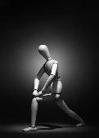 | Touching  Moving  Hands-on learning  Interacting with objects  Doing something physical while learning | Choose projects that let you build, create, shape with hands, Use objects to help you remember people, places things, Volunteer/participate in class
Music/Rhythmic | Rhythmically  Musically  Making up melodies | Create musical jingles to aid memorization, Study for test etc. with quite music in the background, Rhythmically read notes out loud
Interpersonal | Sharing  Comparing  Relating  Cooperating with others  Interviewing | Study with a focused partner, Ask frequent questions of others to gain information, Participate in class discussions, Discuss ideas with others
Intrapersonal  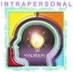 | Working alone in own space  Self-pacing instruction  Reflecting | Organize your study place and time, Take time to think about the things you are learning, Research ideas in depth

Learning Styles Assignment

Name: _____________________ Period: ____ Date: ___________________
Choose one class and use your best Learning Style to complete the assignment.

Describe what you did and how it worked for you.

Parent signature: ________________________

Learning Styles Assignment (Example)

Name: _____________________ Period: ____ Date: ___________________
Parent signature: ___________________________________________

Circle one
My best way to learn is: Choose one class and try using a study technique you learned.
Visual/Spatial Class? _________________________
Verbal/Linguistic
Mathematical/Logical. What did you try? _________________
Bodily/Kinesthetic_______________________________
Musical/Rhythmic_______________________________
Interpersonal
Intrapersonal. Did it work? (Explain)__________________________

Will you use it again?

Will you use it again? ______________

