Classroom Counseling Lesson Plan
Lesson Title | Grade Range | Time Needed
Color Me | K-2 | 45 minutes

Domain | Mindset Standards | Behavior Standards
Career | 5 | SMS10

Learning Objectives:
- Become aware of careers in the home, community and school environment
- Recognize that access to occupations should not be defined or limited by diverse backgrounds
Supplies/Materials:
  - “Color Me” handout (attached)
  - Crayons, pencils
Outline:
- Ask students if they have ever thought about why people choose different jobs. Reinforce that everyone is unique; there is no one in the world exactly like them, and this is one of the reasons they are special!
- Tell students today they will be learning about differences.
- Distribute the “Color Me” handouts, depending on the student’s gender.
- Instruct students to color their pictures while listening to the following directions:
  - Color the hair the same color as your hair.
  - Color the eyes the same color as your eyes.
  - If you like to play with just a few friends, color the shirt blue. If you like to play with a lot of friends, color the shirt red.
  - If your room is messy, color the shorts/skirt yellow. If your room is clean, color them green.
  - If you are right-handed, color your hands orange. If you’re left-handed, color your hands purple.
  - If you like to play outside the most, draw a ball in one hand. If you like to inside the most, draw a book in one hand.
  - If you like school, color the shoes red. If not, color the shoes blue.
  - If you like nighttime best, make a moon next to the boy or girl. If you like daytime best, make a sun.
  - If you like cold weather the best, make a snowman. If you like hot weather best, make green grass.
  - Draw a picture of your favorite thing to eat by your head.
- Collect all of the drawings and show them to the class. Have students try to guess whose picture it is.
- Ask the students to share what they want to be when they grow up.
- Discuss how everyone is different, how we all like different things, and that all of them will have different jobs that relate to their special and unique characteristics.
PROCESS QUESTIONS:
- What did you notice about all of the pictures we drew?
- How might your differences lead you to different jobs when you grow up?

Adapted from:
Omaha Public Schools Career-Occupational Elementary Guidance Curriculum K-6. (2006).

“Color Me”
Name: _________________________
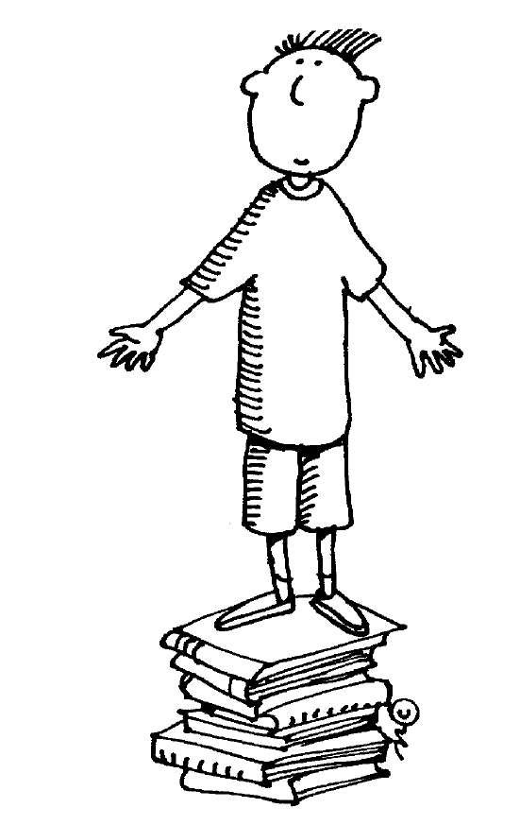

“Color Me”
Name: _________________________
