Classroom Counseling Lesson Plan
Lesson Title | Grade Range | Time Needed
College VS Elementary | 3-5 | 20-30 minutes

Domain | Mindset Standards | Behavior Standards
Career/Academic | MS1, MS2, MS3, MS4, MS5 | LS1, LS4, LS6, SMS1, SMS2, SS3, SS4, SS6, SS7, SS9

Learning Objectives:
Students will be able to:
- Identify similarities and differences between primary grades and post-secondary school.
- Recognize personal strengths and weaknesses as a student.

Supplies/Materials:
- College VS Elementary worksheet
- Describe a Good Student Worksheet
- Writing utensil
Outline:
- Counselor should begin lesson by discussing a student’s role while at school.
  - Sample Discussion Questions:
    - What is your responsibility as a student?
    - How do you know when you are being a good student?
- Counselor should then discuss goals beyond high school.
  - Sample Discussion Questions:
    - What are your plans after you graduate high school?
    - What things do you need to do to reach your goals?
- Have students complete College vs Elementary worksheet
  - Students should make a list of things that will only happen in college, things that will happen only in elementary school, and things that will happen in both.
  - You may want to have students work in small groups.
- Counselor should discuss how individuals have the role of a student in both environments.
- Have students complete describe a good student worksheet.
  - Students should write a word or phrase in each star that describes a good student.
  - You may want to have students work in small groups.
- Counselor should end lesson by reviewing the information discussed.

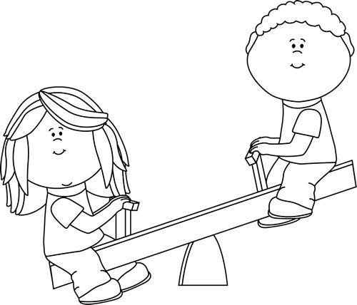
College VS Elementary

College | Both | Elementary

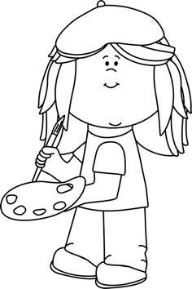
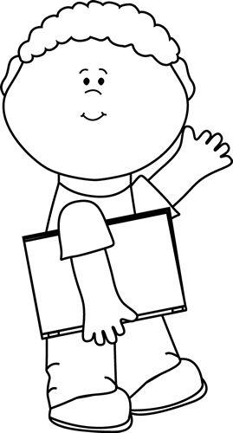
Describe a Good Student

