Classroom Counseling Lesson Plan
Lesson Title | Grade Range | Time Needed
Career Guessing | K-2 | 20-30 minutes

Domain | Mindset Standards | Behavior Standards
Career | MS5 | LS1, LS2, SMS2, SS1, SS3

Learning Objectives:
Students will be able to:
- Identify what a career is
- Identify why different careers are important in our community
Supplies/Materials:
- “Whose Vehicle is This?”
- Posters
- Drawing paper
- Crayons/markers
Outline:
- The counselor should begin the lesson by asking about careers
  - “What is a career?”
  - “Where can you find careers?”
- Play “Whose Vehicle is this?”
  - Students guessed which career the vehicle would be used for.
  - Discuss why each career is important in our community.
- Give each student a piece of drawing paper and a vehicle page.
- Have students draw a picture of a person that does the job associated with the vehicle they get.
  - May want to discuss how careers are not gender specific.
- Counselor will end lesson by reviewing information discussed in the lesson.

Whose vehicle is this?

Whose vehicle is this?

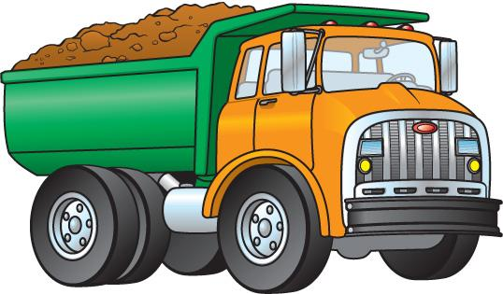
Whose vehicle is this?

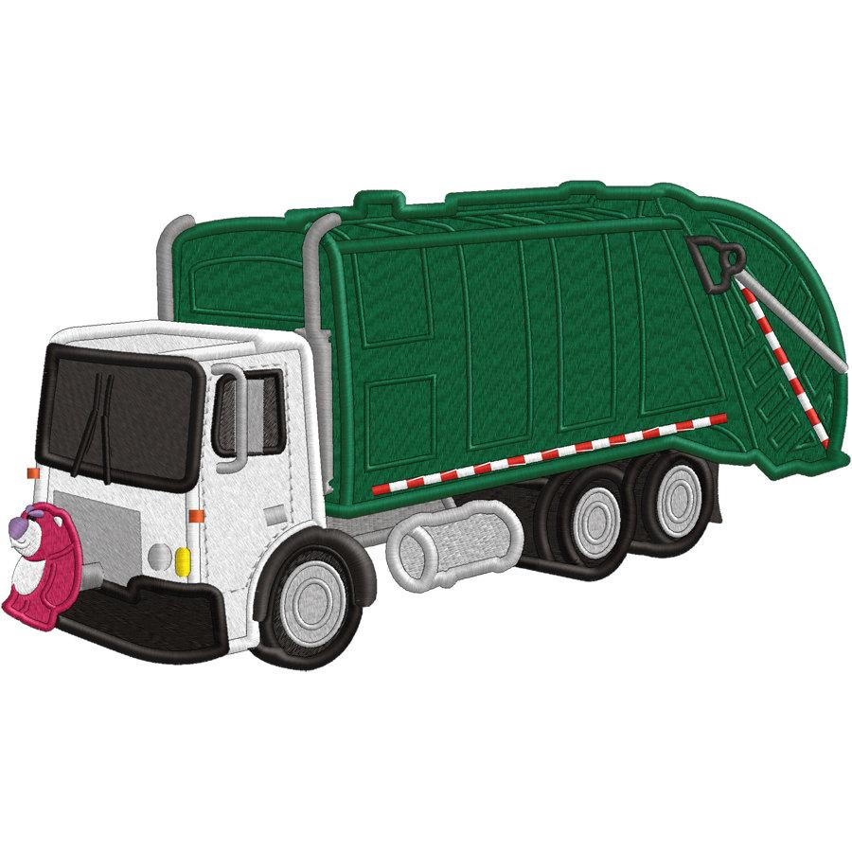
Whose vehicle is this?

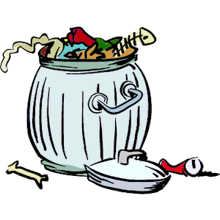
Whose vehicle is this?

Whose vehicle is this?

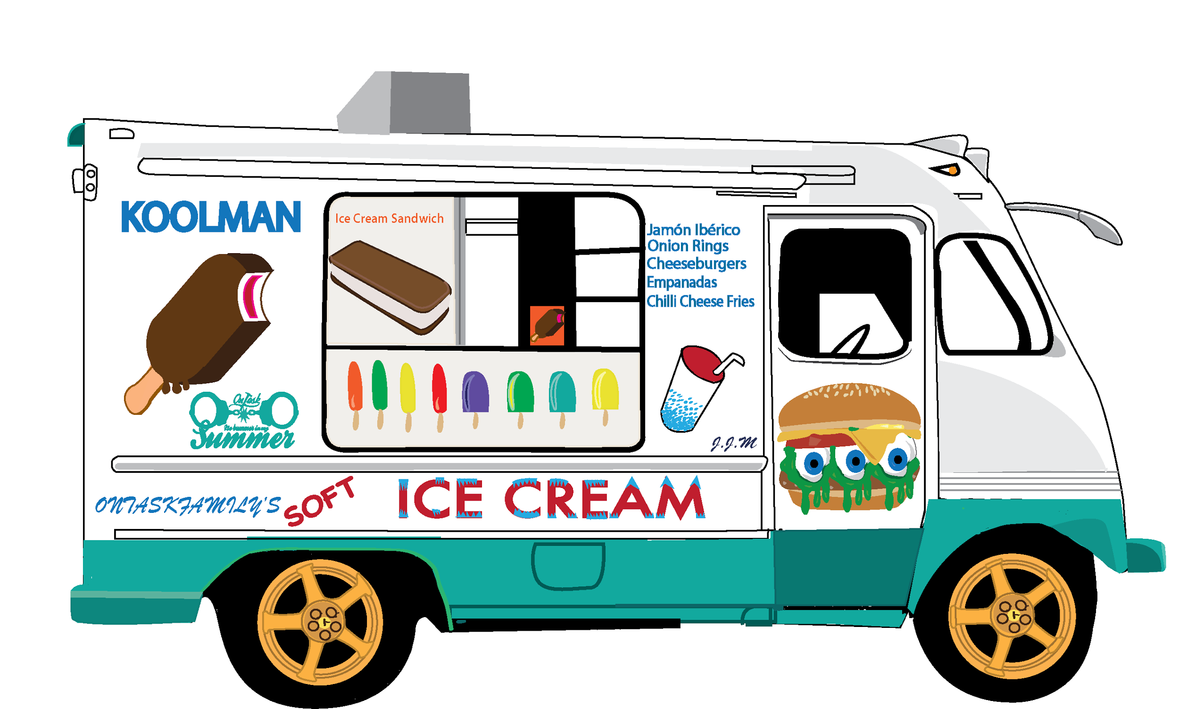
Whose vehicle is this?

Whose vehicle is this?

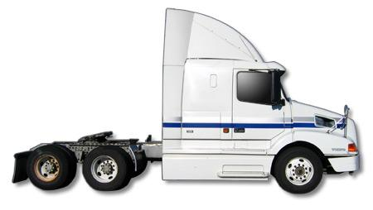
Whose vehicle is this?

Whose vehicle is this?
