Future Planning
SDMyLife Magazine 2014-2015
Introduction to Career Decision Making
6-8th Grades Career Development
Essential Questions:
- What are Career Clusters and Pathways and how can they assist me in identifying my career interests?
- What Career Clusters and Pathways interest me and why?
- Which careers are related to the Clusters that interest me? Which of these careers interest me and why?
- What are the similarities and differences between my career interests and those of my classmates?
- What are the similarities and differences in my career and cluster interests and those recommended to me by the Career Matchmaker?
Materials:
- SDMyLife magazine 2016-17
- Sticky notes
- Names of the 16 Career Clusters posted around the room, or written on the board (with space underneath), or on chart paper, etc. Students will be placing sticky notes underneath each cluster.
- Computers and SDMyLife log in information
Time: 1-3 class periods (Time will vary depending on how many of the activities are completed.)

Summative Evidence: Students will complete the lesson, share with partners, class, or group, and complete the Career Matchmaker, save 3 careers, and save 3 Career Clusters to their Learning Plans in SDMyLife.

Introduction: 10-15 minutes
Students will work in partners or groups of three, depending on number of students. Hand out 2016-17 MyLife magazines and ask students to skim through the magazine and verbally share responses as they find the following items to become familiar with the magazine. Post this list on the board or a slide to meet the needs of both visual and auditory learners.
- Name one Hot Career.
- What is a NEW career? Do you know anybody who works in a NEW career?
- Skim through the magazine and ask students to find any words that are unfamiliar to them. As students share their words, jot them down in a list and ask for definitions or clarify the meaning for the students before moving on to new words. Be sure to clarify meanings or provide examples before moving to the next questions.
- Turn to p. 8 and find the definitions for Career Cluster and Career Pathway. Write or display the definitions on the board as a student reads them or use a projector to post the electronic version of the magazine to display the definitions. Ask students to put the definitions in their own words and share them with a partner. Then ask for one or two sets of partners to share their responses with the large group. Continue to ask for definitions as needed to check for understanding of the terms Career Cluster and Career Pathway.

Instruction 25-30 minutes
- Have students work in partners to review pgs. 10-43 to read about the 16 Career Clusters and Pathways. Hand out two sticky notes to each student.
- Instruct students to select TWO Career Clusters that seem interesting. On each sticky note, students should write the name of the Career Cluster, one complete sentence about why it seemed interesting, and their name at the bottom.
Arts, AV, Technology
I like to draw and make graphics on the iPad, and my favorite class is computers.
Rebecca

- Students should share their sticky notes with their partners and discuss their thoughts on the Career Clusters.
- After students have completed the sticky notes AND shared with their partners, have them neatly place their sticky notes under the signs or other method you used to display the 16 Career Clusters. This will create a visual of which Career Clusters seem to be of the most interest to your students. Ask for volunteers to share which Clusters they were interested in and why. Ask students how they interpret the way the Clusters are represented by the sticky notes. What might this tell us about our class, ourselves, our interests, our skills?
Day 1 Closure/Wrap Up 10-15 minutes
- Conclude with further discussion. Was anybody surprised by people’s choices of Career Clusters? Why? Did anybody have specific reasons for selecting a cluster like, family member works in that cluster, visited with a person who does that job or have seen the job in action, possibly work in that career field for a summer job or as a helper? Conversely, ask students why they DIDN’T select certain Career Clusters. What do they know about it? Is it a lack of understanding of what jobs are included? Do they know individuals who do that work? Ask for examples of jobs that fall under each cluster and/or names of people they might know who work in those clusters. It will be helpful to prepare of list ahead of time that could include individuals or businesses that might be well-known in your community, so students have common examples if they still aren’t completely sure of what jobs a Cluster might include. Ask students to count the number of sticky notes under each cluster and jot it down to make a quick graph or chart or other visual representation of the data. Suggestion: Take a picture of the various Clusters and sticky notes if you are short on time in order to graph it later, if desired.

Days 2-3 Extension Activities-Cluster Research and Saving Careers to PLP
time will vary depending on activities selected
- Have students log on to SDMyLife.com and click Careers from the top menu bar.
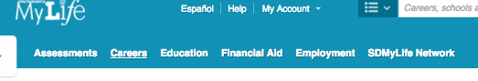

- Once they are in the Career section, have them select the 16 Career Clusters tab.
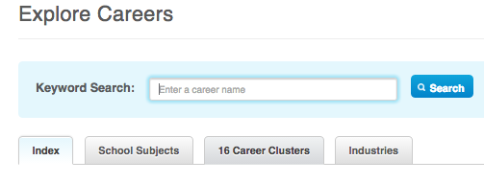

- Allow students about 25 minutes to select a few clusters and read the cluster and pathway descriptions. Encourage students to select the two clusters they were interested in during the magazine lesson activity, as well as any others they want to research.

- Direct students to move back to a cluster of high interest and click the Related Careers tab to display a list of careers.
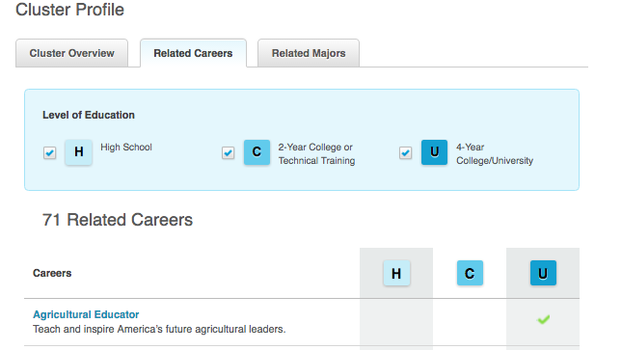

- Direct students to select careers of interest from the lists and to review the information. By clicking the name of a career, student will open its Career Profile. The Career Profile will include descriptions, information about required education, earnings, career paths, etc. They may continue to look at careers within the same cluster or go back and look at careers in different clusters. Once students have identified 3 careers of high interest, instruct them to save the 3 careers to their PLP by clicking the blue SAVE TO MY PLP button located at the top of each career profile.
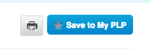

Days 2-3 Extension Activities-Completing the Matchmaker
Time will vary depending on activities selected. Plan on at least 25 minutes to log on, read directions, and complete the Matchmaker.
- Students will have just completed reviewing Career Clusters and saving some careers of interest. Ask for a few students to share what careers they saved and why, and what some career interests of the class might be. Explain that now students have gotten a little familiar with SDMyLife and Career Decision Making based on what the students selected, they are now going to take a Career INTEREST Inventory, which will match their interests with suggested careers. It might be helpful to have logged in with a projector to display the Matchmaker as you are going through the directions. Share the interest categories either by projecting the site or showing them the screen shot below in the directions. Carefully explain the directions: “The Matchmaker has a total of 39 questions. There are no right or wrong answers. You will be asked to rate how much you like or dislike a variety of activities, like working inside all dy. Try not to select DOES NOT MATTER very often, as you won’t get accurate career matches. Read the description of the activities carefully and answer honestly. If you answer that you like working inside very much, then you are telling the program to find you career matches that require inside work for much of the work day. The Matchmaker program is working to put together your answers with a list of 40 career suggestions based on your likes and dislikes. The list is only a suggestion and does not mean you will choose one of those careers. It’s to help you get an idea of what careers might match what you like to do. When you are done, you may search through the list of suggested careers while you wait for others to finish.”
- Optional: When students have completed the Matchmaker, the results will automatically be saved. Students will see the list of 40 suggested careers, and each career is linked to a Career Profile. They looked at career profiles previously while searching and saving careers. You may have them click on the career profiles to read about the suggested careers, if desired.
- Optional: You may also direct students to IMPROVE MY RESULTS. The Matchmaker has 39 questions, but students can answer more questions to continue to fine-tune their list of suggested careers. This is not required, but will update their list based on how students answer further questions. Once the Matchmaker has been completed and students reviewing their career suggestions, they will see IMPROVE MY RESULTS on the left side of the screen. You can direct students who completed the assessment to continue to ANSWER MORE QUESTIONS until everyone is done with initial 30 questions of the Matchmaker.
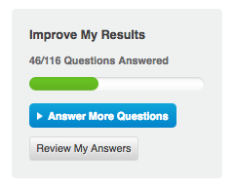

- Have students log on to SDMyLife.com and click Assessments from the top menu bar. Once they are on the Assessments page, have them select START MATCHMAKER.
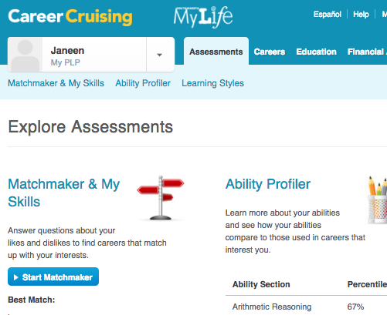

- Instruct students to give the Matchmaker a label (name). It is recommended to include the date; for example, Matchmaker 1 September 18, 2016.
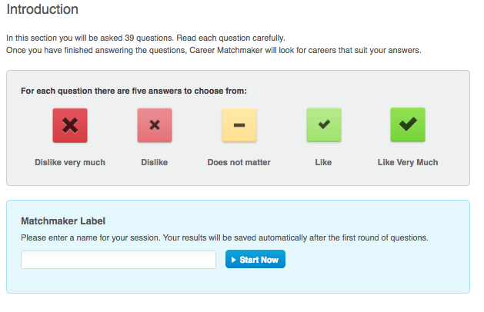
- Once students have labeled, the Matchmaker, they may click START NOW and complete the assessment.
- Once students have completed the assessment, direct students to do any or all of the OPTIONAL activities as described above.
- Recommended: As students investigate some of the careers from their suggested list, have them save additional careers to their PLPs.

Days 2-3 Extension Activities-Saving Career Clusters to PLP
Time will vary depending on activities selected. If students are already logged in, allow 10-15 minutes to select and save Career Clusters.
- Have students log on to SDMyLife.com and click My PLP from the top left side of the screen.
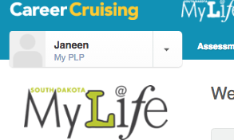
- Select MY CAREERS from the left side menu, and then click MY SAVED CLUSTERS.
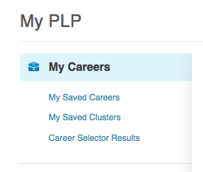
- If students completed the Matchmaker already, two suggested Career Clusters will appear at the top of the list. These are the Clusters that best matched the careers suggested to the students as a result of indicating their interests when completing the Matchmaker.
- Direct students to check the box next their preferred Career Clusters and add a comment explaining why s/he is interested in the cluster. It is recommended to save at minimum 3 Career Clusters.
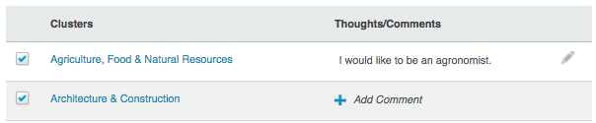

Days 2-3 Closure/Wrap Up
Time will vary depending on activities selected. You may choose to do part of the wrap up after each activity in SDMyLife is completed.
1. Have a brief discussion about which clusters and careers students reviewed and saved. You can use the ‘ticket out the door’ for each student to share, do a ‘think pair share’ or put students in groups or inside-outside circles to share the following:
- one NEW thing they learned or that surprised them
- one of their saved clusters and the reason the student chose to save it
- one of their saved careers and the reason the student chose to save it
- one thing they would like to research further or learn more about; i.e. students might like to talk to a person who has that career, do a job shadow, or visit a business, or find out where those individuals received training, etc.
- Did any of the careers suggested match ones students had saved the previous day?
- Did any of the clusters suggested match ones students had saved the previous day?

