Career Decision Making-Career Planning Activities, Goals, & My Skills
SDMyLife Magazine 2014-2015

9-12th Grades Career Development
Career Planning Grades 9-10
Essential Questions:
- What is a Career Planning activity and how many have I completed?
- How do my skills and attributes align with my career interests?
- How can my skills and attributes assist me in selecting a career path?
Materials:
- SDMyLife magazine 2016-2017
- SDMyLife login information/computers
Time: 2 class periods depending on selected activities

Summative Evidence: Students will complete an introductory classroom activity and then log on to SDMyLife to record Career Planning Activities, create Career & Life Goals, and complete the My Skills assessment.

Day 1 Introduction: 10 minutes
- Ask students to brainstorm a short list of 4-5 ways they might learn more about a career. How would they learn what an accountant does or how much education a person needs to have to be a doctor? Generate a list of activities they might do or people who might be able to help them learn about careers. Students can verbally share their ideas. Assist them by asking if they have done anything in their classes, with parents, school counselor, through volunteer activities, paid jobs, etc.

Instruction time 30-40 minutes
- Hand out the MyLife 2016-17 Magazine. Working in pairs (if desired), challenge the class to find 15 examples of ways they could find out more about careers or people they might ask for help in learning about careers. Be ready to jot down their examples on the board or type on the computer if using a project. Call on each partnership to share one idea from the magazine
(examples might include Cluster Camps on p. 72; visiting any of the universities/tech institutes-ads run throughout the magazine; earning one of the certifications on p. 67; get involved with student government; job shadows, etc.) Write down one idea from each partnership at a time going back through the class until you reach a class total of 15 without repeating any ideas. Ask students if they have completed any of the items on the class generated list.

- Direct students to log on to SDMyLife and go to their PLP.
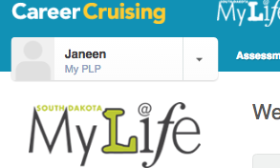
- Select My Goals & Plans from the PLP menu to open up the menu below.
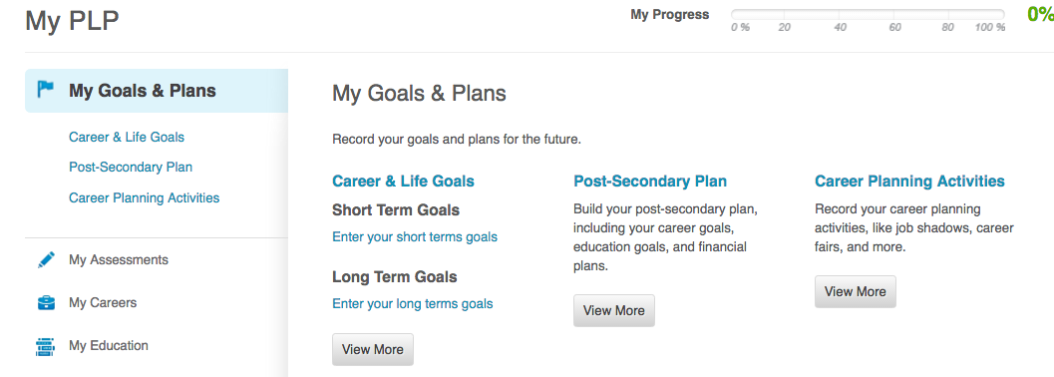

- Direct students to click CAREER PLANNING ACTIVITIES and begin to add any career planning activities they may have completed.
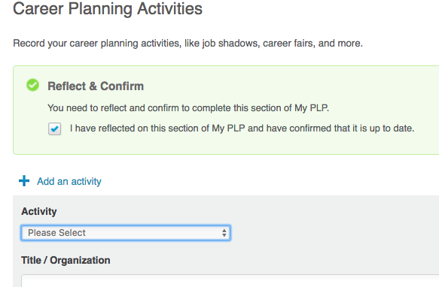

- Students will click ADD AN ACTIVITY and use the dropdown menu to select from an activity and to complete the required fields: title/organization, start and end dates, description of activity, etc.
- Assist students in adding at least 1-2 activities, if possible. Remind students that activities do not need to be school related. They could be work, family, club, religious group, volunteer related, etc.
- Direct students back to the PLP and MY GOALS & PLANS section, and have students click on CAREER & LIFE GOALS.

- Instruct students to develop and add both a short term and a long term goal by clicking ENTER YOUR SHORT/LONG TERM GOALS and typing in their goals. Encourage students to write 1-2 complete sentences. The goals do not need to be academic or career goals, but should relate to things they are working towards. A SHORT TERM goal might be something students can accomplish in the next few months or semester, like getting a part in the school play, getting a weekend job, passing a difficult course, completing a project like working on a car or helping build a fence for your family or neighbor. A LONG TERM goal might be accomplished within the next year or few years like graduating in the top 10% of my class or making it to the state track meet as a senior, or saving up enough money to make a big purchase like a car or motorcycle, computer, etc.
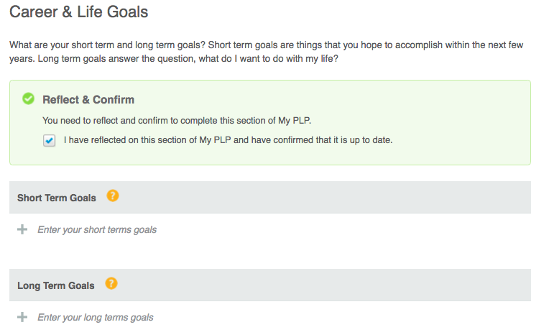

Day 1 Closure/Wrap Up
Conclude with a discussion of Career Planning Activities and any type of these activities that might help them reach their short and long term goals. Challenge students to find examples of careers that align to their short or long term goals. For example, if a student has a goal to get a part in the school play, what careers might align with that goal? (Examples might include acting, directing, makeup, lighting director, set designer, costume designer, writer, musician, etc.)

DAY 2
Materials
- SDMyLife login information and computers
- Basket, hat, or other small container to hold slips of paper or notecards
- Slips of paper or notecards (one for each pair or students or group depending on how you decide to group students)
Day 2 Introduction: 15-20 minutes
- Ask students to share the name of somebody they feel is very skilled or talented, identify what skill or talent that person has, and how that person uses/has used that skill in their career. Allow a few students to share. Most likely students will identify famous athletes or musicians, which will be fairly obvious examples of skills used in careers. Tell students that skills and talents often lead people into successful careers, but the key is to be able to think beyond the obvious skills of singing and becoming a singer or shooting baskets and becoming a basketball.
- Each pair or group of students is going to draw a card with a skill or talent from the basket and try to come up with a list of careers in which that skill would be a good asset. If desired, you could make it a competition to come up with the longest list of careers and the best reasons why that skill is needed in each career listed.
- Possible list of skills to put on notecards: good listener, very organized or good at helping other get organized, skilled reader, skilled writer, helps other people with their problems, able to fix mechanical things, good at coming up with interesting ideas, very friendly and makes people feel welcome, gets along well with everybody, is able to follow directions well, likes to build things, knows how to work many computer programs, likes to talk to others, works well with others or in group settings, works well alone/independently, able to show others how to do things or complete tasks, has a good memory, enjoys being outside, likes animals, likes to follow step-by-step processes, able to ‘picture’ what the finished product will look like at the start of a project, is physically strong, etc.
- Set a timer if desired, and ask for pairs to share their lists.

Day 2 Instruction time 20 minutes
- Instruct students to log on to SDMylife and click on ASSESSMENTS.
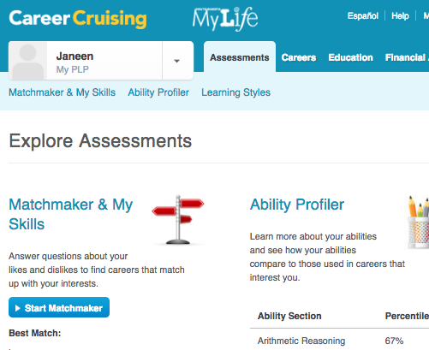
- Under the Matchmaker and My Skills, students may see START MY SKILLS or they may need to open their saved Matchmaker and find the My Skills on the left side of the Matchmaker screen.
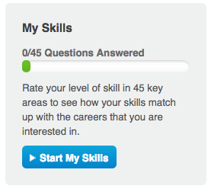
- Instruct students that like the Matchmaker asked students how much they liked or disliked an activity, the My Skills assessment is going to ask them how skilled they believe they are at various activities. It is important for students to be honest in how they assess their skills. The program will then align how students assessed their skills with how well those skills match with the careers suggested by the Matchmaker.
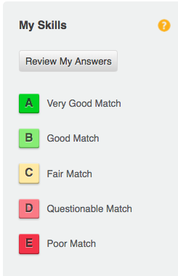
- When students have completed the My Skills assessment, their original set of careers suggested by the Matchmaker will appear with an additional column showing the level of the match of career to self-reported skills as shown in the table above.

Day 2 Closure/Wrap Up
Conclude with a discussion of how the students felt their skills matched with their suggested list of careers from the Matchmaker. Remind students that they can review their answers from the My Skills assessment if they felt they were not as accurate in identifying their skills as they could have been. Ask students their thoughts about the possibility of improving skills in order to go for a career of interest. Are there any skills they would like to improve upon?

