Future Planning
SDMyLife Magazine 2014-2015
Academic Planning-School Searches
11-12th Grades Academic Planning
Essential Questions:
- What are my post-secondary plans?
- What steps can I take in high school to prepare for my post-secondary plans?
- How can I start searching post-secondary education options?
- Which post-secondary education features are important to me?
- What are the similarities and differences in my post-secondary education interests and those recommended to me by the School Selector?
Materials:
- SDMyLife magazine 2016-17
- Computers and SDMyLife log in information
Time: 1-2 class periods (Time will vary depending on how many of the activities are completed.)
Summative Evidence: Students will complete the School Selector, search post-secondary education options, save 3 schools, save 3 majors, and use the Compare Schools and School Selector features and save results to their Personal Learning Plans in SDMyLife. Items completed will vary depending on how many class periods are spent on academic planning.
Introduction: 10-15 minutes
Hand out 2016-17 MyLife magazines. Lead students in a discussion about post-secondary planning. Ask students to skim through the magazine and identify any features that refer to post-secondary planning and to share them with the class. Examples include:
- Your Road to the Future section (grade levels with lists of planning activities)
- Finding Your Perfect Match p. 44-45
- Applying High School to Real Life p. 46-47
- Be Hard on Yourself p. 48-49
- Test Yourself p. 56-57
- Understanding Financial Aid p. 58-59
- Any pages with post-secondary education information
- Answers will vary. Encourage students to share the sections and to turn to those pages to follow along with the discussion. Ask how many students have completed (or researched/participated in) each of these items, share their experiences, how it helped them, or steps they took to complete items, and what they learned, and plan to do next.
Instruction 25-30 minutes
- Have students log on to SDMyLife.com and click Explore Education Options from the left side menu.
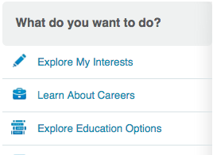

- Students will begin to search for schools and majors. Students should save 3 schools and 3 majors during this exploration time. Remind students they are always able to delete anything that is saved if they change their minds. Students can also save more than 3, if desired.
- Instruct students to begin searching for SCHOOLS by either typing the name of a school in the search box or clicking on a state in the US map where they might be interested in attending post-secondary education.
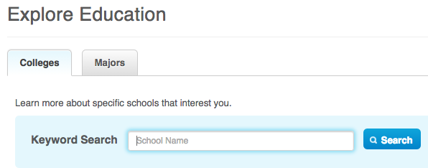
- Once students have selected a school and clicked on it, they will have opened the school profile. Encourage students to read through the provided information, which includes cost, degrees offered, activities, student life, etc. Students can save the school to their PLP by clicking the SAVE TO MY PLP button in the upper right hand corner of the school profile.
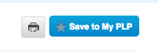

- Allow students to continue searching until they have saved 3 schools.
- Once students have saved 3 schools, direct them back to the EXPLORE MY EDUCATION OPTIONS and have them begin to search MAJORS by typing in the search box or selecting one of the categories listed. Allow time to search and save 3 MAJORS to their PLP.
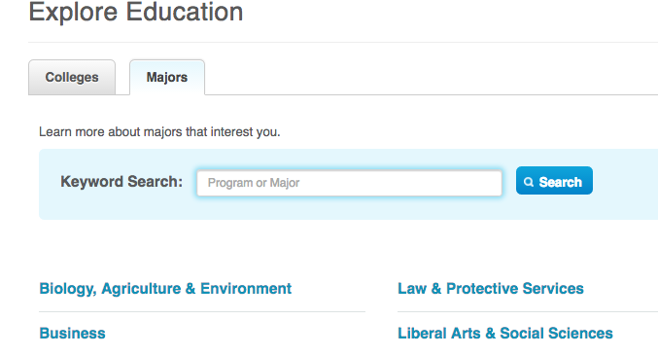

Day 1 Closure/Wrap Up 10 minutes
- Ask students to share schools and majors saved. Why did they make those selections? Ask them to share details about the schools and majors. You can quickly do a 3-2-1 out the door activity: 3 new pieces of information they discovered; 2 items they want to discuss with family, friends, teachers, counselor, etc.; 1 question they have or need to research further.

Day 2 Extension Activities-Saving School Selector to PLP and Compare Schools Feature
time will vary depending on activities selected
- (5-10 minutes) Begin by describing the work students will complete today: the School Selector and Compare Schools. The School Selector will match schools with criteria the students indicate while completing the questions. Students will need to have save majors prior to completing the School Selector. The Compare Schools feature will allow students to compare 3 schools side-by-side-by side in one easy to read and navigate section.
- Share the following information with students: “By now you have probably completed the Career Matchmaker, maybe even when you were in middle school or earlier in high school. The Matchmaker used your answers to suggest a list of careers, and the School Selector will do the same thing for post-secondary education options. Based on the criteria you set as you go through the questions, the School Selector will suggest schools that match some or all of your criteria. Depending on how you answer the questions, you might not have any PERFECT matches, but you will notice tabs that show schools that matched 5 out of 6 criteria, etc. YOU MAY GET A MESSAGE THAT SAYS NO SCHOOLS MATCHED ALL YOUR CRITERIA. THAT DOESN’T MEAN THERE ARE NO EDUCATIONAL CHOICES FOR YOU. LOOK AT THE NEXT TAB FOR CLOSE MATCHES TO FIND THE SCHOOLS THAT MATCHED SOME OF YOUR CRITERIA. YOU CAN ALSO USE THE TABS TO REVIEW YOUR CRITERIA TO CHANGE YOUR ANSWERS AND TO COMPARE SCHOOLS YOU ARE INTERESTED IN TO YOUR CRITERIA TO FIGURE OUT WHY CERTAIN SCHOOLS MAY OR MAY NOT HAVE APPEARED ON YOUR LIST.” Make sure to remind students to answer honestly and to save their results to their Personal Learning Plan.

- Have students log on to SDMyLife.com and click Explore Education Options from the left side menu.

- Once they are in the Explore Education Options section, have them select the School Selector from the right side of the screen.
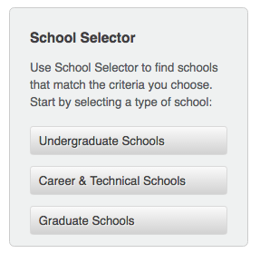
- Allow students about 15-20 minutes to complete the School Selector of choice (undergraduate or Career & Technical Schools), change their criteria, and compare schools of interest to their criteria as indicated by the tabs. Remind students to save their School Selector results to their Personal Learning Plans.

- Direct students to move back to the Explore Education Options page and to select the Compare Schools feature on the right side of the page.
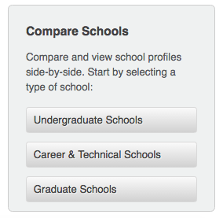

- Direct students to select undergraduate or Career & Technical Schools and to proceed by clicking the blue Add School button to select schools to compare.
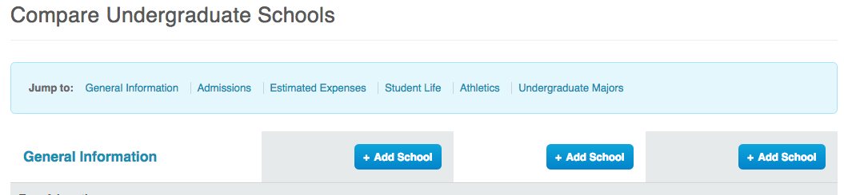

- Allow students about 15 minutes to complete at least one Compare Schools search cycle. Remind students they can log on to SDMyLife at any time and do more searching, save more schools and majors, or continue to compare schools.
Day 2 Closure/Wrap Up 10 minutes
- Ask students to share what they learned from the School Selector? Did anybody have perfect matches? Did anybody go back and change their criteria? What happened when the criteria was changed? Have at least 3-4 students share an interesting fact they discovered when doing the Compare Schools feature. What are some next steps students will take as a result of completing these 2 sections of the Personal Learning Plan?

